Project 3 – Options Pricing Dashboard

Group – Richard Kell, Catherine Logan, Todd Garner

We intend to post a Dashboard on Streamlit that does the following:

1. For 1 stock (preselected – potentially more than 1 stock) pull in via API:
   1. Stock price (possibly more stocks)
   2. Options Chain: (possibly more options chains)

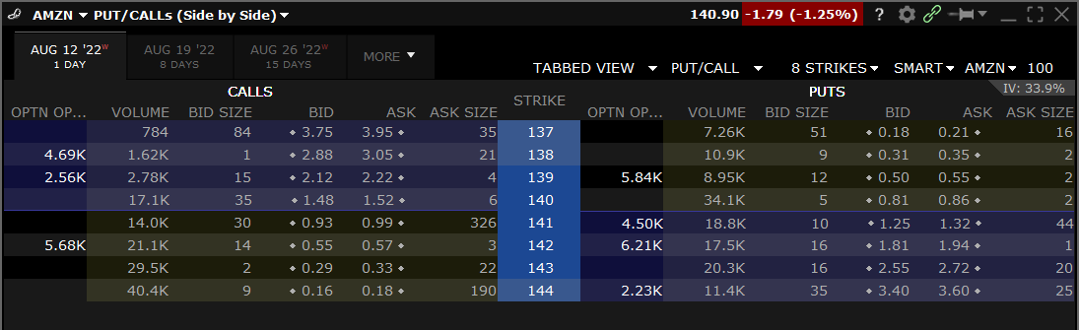

* 1. The Black-Scholes Model to calculate options pricing (to be brief, all variables are known except for the implied volatility):
     1. Sensitivities can be selected by the User:
        1. Timeframe over which the implied volatility can be evaluated.
           1. 1 year
           2. 5 year
           3. 3 months
           4. Etc.
     2. From that selection (possibly more) the program will calculate the options pricing per the Black-Scholes model. Ideally, post them next to the actual pricing in the options chain showing the potential dislocations in pricing.

1. This will exhibit numerous features that we’ve learned in this course:
   1. Streamlit to post the Dashboard
      1. Drop down menu to select the timeframe over which the implied volatility is calculated. In reality, this is the timeframe for the Machine Learning model that will calculate the implied volatility
   2. Visualization of the results (some of the results – TBD)
   3. Machine learning to arrive at an “implied volatility.” Perhaps this is a selection that the user can make in a drop down menu. What indices are included.
      1. S&P500
      2. NYSE
      3. NASDAQ
      4. Dow 30
      5. Dow transports
   4. Lots of Python code
   5. A bot to ask the user questions (still formulating this, but a bot that has some useful function)